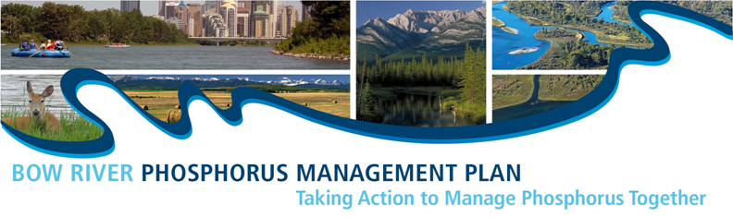

EXECUTIVE SUMMARY
Heightened nutrient levels in the Bow River downstream of Calgary have long been a concern. In the 1970s and 1980s, high nutrient levels resulted in excessive aquatic plant growth resulting in low dissolved oxygen and occasional fish mortality. An interim policy on effluent limits was released by Alberta Environment in 2008. This policy required that a regional nutrient load reduction plan be developed for reaches at risk of exceeding water quality guidelines. At the same time the Government of Alberta was transitioning to an environmental management approach that addresses the cumulative effects of resource management decisions and considers the environmental, economic and social implications of development for an entire region.
In 2011, Alberta Environment and Sustainable Resource Development (ESRD) invited contributing parties in the affected reach of the Bow River to initiate a voluntary, collaborative process to address phosphorus loadings, not just from point sources such as the wastewater treatment plants, but from non-point sources as well.
The Bow River Phosphorus Management Plan (BRPMP) is a strategic plan to address sources of phosphorus in the middle reach of the Bow River between the Bearspaw and Bassano Dams. It is the culmination of work by contributing parties from government and non-government, urban and rural sectors, and a wider constituency of subject matter experts who contributed on task teams to define the issue, establish goals and objectives, and recommend strategies and actions to manage phosphorus in the Bow River.
The BRPMP seeks to enable management actions to meet social, economic and environmental outcomes now and into the future. This is a proactive, place-based, knowledge-driven and adaptive plan with collective action by, and accountability of, contributing parties.
The Bow River Phosphorus Management Plan Area
The Bow River flows through the natural sub-regions of the Rocky Mountains, Foothills Parkland, Foothills Fescue and Mixed Grass (GOA 2006) and encompasses an area of 12,481 square kilometres (1,248,147 hectares or 3,084,227 acres). This amounts to just two percent of Alberta’s total area, yet approximately one third of the population of Alberta lives in the planning area, making this a high risk area for phosphorus loading in the province.
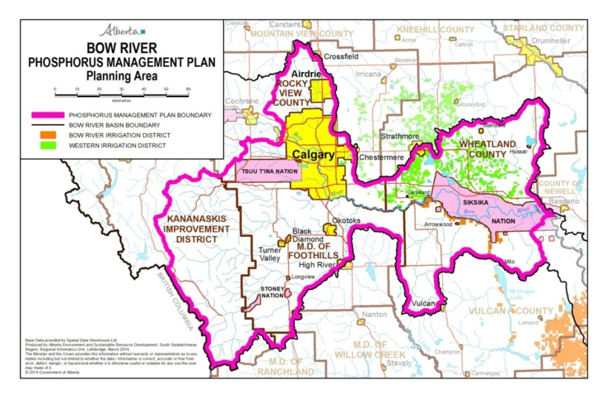
The planning area includes:
- the urban areas of Calgary, Airdrie, Strathmore, Okotoks, High River, Turner Valley and Black Diamond;
- the rural municipalities of MD of Foothills, Rocky View County, Wheatland County and Kananaskis Improvement District; and
- the lands of Stoney Nation – Eden Valley, Tsuu T’ina Nation and Siksika Nation.
- the lands and canals of the Western Irrigation District and the Bow River Irrigation District

Where Does Phosphorus Come From?
Phosphorus is a naturally occurring element. In water, it occurs as dissolved phosphorus or in particulate form bound to suspended soil particles. On land, it occurs naturally in soil and is taken up by plants as they grow. Phosphorus is also introduced, for example, through the application of chemical fertilizers.
Sources of phosphorus in the Bow River basin include: plant material, soil, animal waste, treated wastewater effluent, fertilizer in runoff water, sediment from eroding riverbanks, and dust fall (atmospheric deposition). Airborne phosphorus originates from sources such as industry and vehicle emissions, forest fires, and from wind picking up dust, soil and fertilizer and becomes part of the stormwater runoff. Phosphorus captured by wind and falling precipitation is not well studied in this area but is a source of the total phosphorus in the planning area.
Planning Context
The BRPMP objective to manage to the current water quality conditions aligns with the Surface Water Quality Management Framework (SWQMF) that has been developed under the draft South Saskatchewan Regional Plan. The current water quality conditions are assessed using median concentrations measured monthly at several locations in the Bow River over the period of years from 2008-2011. These median values are essentially the same as the trigger values in the SWQMF for the Bow River. The trigger thresholds for phosphorus in the Bow River were established based on the water quality observations from 2004-2009 and are considered acceptable conditions. The actions contained within the BRPMP are a proactive management approach to avoid exceeding the trigger thresholds into the future. Because the SSRP requires that water quality be monitored and assessed annually, the results will be available to inform the implementation phase of the BRPMP. The SWQMF is expected to be legislated under the Alberta Land Stewardship Act in 2014.

Signatories
The following organizations make up the Steering Committee of the Bow River Phosphorus Management Plan. Their signatures represent a commitment by their organization to pursue the strategies and actions relevant to their activities and to implement the actions that their organization is capable of achieving over the next several years. For best results, collaboration and coordination among organizations is encouraged and coordinated through the BRPMP Implementation Committee.
- Agriculture and Agri-Food Canada
- Alberta Agriculture and Rural Development
- Alberta Environment and Sustainable Resource Development
- Bow River Basin Council
- Calgary Regional Partnership
- City of Airdrie
- City of Calgary
- Corix Wastewater Treatment Operators (Heritage Pointe)
- Crop Sector Working Group
- First Nations – Stoney Nation
- Intensive Livestock Working Group
- Irrigation Districts
- Municipal District of Foothills
- Rocky View County
- Rural Non-Government Organizations – represented by Ducks Unlimited Canada
- Town of Okotoks
- Town of Strathmore
- Urban Non-Government Organizations - represented by Alberta Low Impact Development Partnership
- Watershed Stewardship Groups – represented by Highwood Public Advisory Committee
- Wheatland County

Please indicate your support for the Bow River Phosphorus Management Plan by signing in the box below. Signatures will be scanned and transferred to a signature page.

Please return completed form to:
Monique Dietrich, ESRD, 3rd fl Deerfoot Square, 2938-11 St NE, Calgary, AB T2E 7L7
Monique.Dietrich@gov.ab.ca

Statement of Response
Organization Name: _____________________________________________________________
Contact Information: _____________________________________________________________
_____________________________________________________________________________
Comments: ____________________________________________________________________
_____________________________________________________________________________
_____________________________________________________________________________
_____________________________________________________________________________
_____________________________________________________________________________
_____________________________________________________________________________
_____________________________________________________________________________
_____________________________________________________________________________
_____________________________________________________________________________
_____________________________________________________________________________
Steering Committee Members (Alternates): Agriculture and Agri-Food Canada - Holly Mayer; Alberta Agriculture and Rural Development (ARD) - Andrea Kalischuk (Janna Casson); Alberta Environment and Sustainable Resource Development (ESRD) [Project Sponsor] - Heather Sinton (Rob Simieritsch); Alberta Low Impact Development Partnership - Leta van Duin (Rene Letourneau); Bow River Basin Council - Mark Bennett (Mike Kelly), Calgary Regional Partnership - Bob Miller (Darrell Burgess); City of Airdrie - Scott Fediow (Archie Lang); Crop Sector Working Group - Sharon McKinnon (Elaine Bellamy); Ducks Unlimited Canada - Tracy Scott; Heritage Pointe - Todd Faith; Intensive Livestock Working Group - Ron Axelson; Irrigation Districts - Erwin Braun (Richard Phillips); Municipal District of Foothills - Heather Hemingway (Spencer Croil); Rocky View County - Tim Dietzler; Stoney First Nation - Bill Snow (Marie Kootenay); The City of Calgary - Margaret Beeston (Yin Deong, Edith Phillips, Lily Ma); Town of Okotoks - Steph Neufeld; Town of Strathmore - Jesse Parker (Bryce Mackan); Watershed Stewardship Groups - Shirley Pickering; Wheatland County - David Churchill (Sarah Schumacher).
Please return completed form to:
Monique Dietrich, ESRD, 3rd fl Deerfoot Square, 2938-11 St NE, Calgary, AB T2E 7L7
Monique.Dietrich@gov.ab.ca

Priority Objectives and Strategies

Improve understanding and change behavior to reduce phosphorus entering the Bow River.
- Strategy: Provide accessible public education programs to all jurisdictions.

Increase knowledge about phosphorus sources, the planning area, and phosphorus management practices.
- Strategy: Explore opportunities to address the cumulative effects of phosphorus in the long term.
- Strategy: Monitor and evaluate water quality conditions in the Bow River basin to establish a baseline and investigate risk to the aquatic environment and potential management actions if phosphorus levels trend upward.
- Strategy: Complete accurate inventory of landscape mapping to determine risk and establish baseline conditions.
- Strategy: Conduct research and fill data gaps to advance knowledge in phosphorus management and mitigation options.
- Strategy: Use models to anticipate new phosphorus loadings as growth occurs in the planning area, and to test current and future scenarios.
- Strategy: Evaluate and align policies.

Reduce additions of phosphorus
- Strategy: Facilitate the adoption of livestock manure nutrient best management practices to reduce phosphorus build up and runoff loss potential.
- Strategy: Reduce urban additions of phosphorus.

Reduce the movement of phosphorus to the river.
- Strategy: Achieve the goal of no further net loss of wetlands in the planning area.
- Strategy: Work toward achieving wetland restoration objectives for the planning area.
- Strategy: Maintain and improve riparian area function.
- Strategy: Reduce sediment loading from regional drainage and return flow channels.
- Strategy: Minimize erosion and control sediment movement
Remove excess phosphorus from water before it reaches the river.

- Strategy: Reduce amount of phosphorus per capita entering the Bow River PMP planning area.
- Strategy: Establish regional watershed targets.
- Strategy: Maximize the effectiveness of Wastewater Treatment Plants to reduce outputs of phosphorus.
- Strategy: Review lagoon Code of Practice and regulations to allow for maximum phosphorus removal.
- Strategy: Ensure quality assurance of current practices for lagoon operations.

Next Steps: Establishing an Implementation Committee
ESRD will take an active role in providing leadership for the establishment and ongoing efforts of the Implementation Committee. Similar to the composition of the Steering Committee, it is anticipated that the Implementation Committee will be largely composed of contributing parties as key implementers (i.e., organizations and individuals who can play an active role in helping to move the actions forward).
The Implementation Committee will make recommendations for renewal of the BRPMP as it progresses and as new information becomes available. Consideration will be given to aligning this with the review period of the South Saskatchewan Regional Plan, which requires annual progress reporting, a five-year formal report and ten-year renewal.
Education and outreach were identified as critical to the successful implementation of the BRPMP. ESRD will establish an Education and Outreach Working Group to move this forward. Provided strong linkages and the element of cross-over exist, this work could be conducted concurrently with the work of the Implementation Committee and in conjunction with the work of the Performance Measures Working Group.
The success of the Implementation Committee and the two working groups will be dependent on the collective action of all contributing parties.

Endorsing the BRPMP
Each of the contributing parties represented on the Steering Committee has demonstrated a commitment to the process of developing the BRPMP. The BRPMP itself recommends strategies and actions that will only be successful if every sector takes responsibility for those elements of the BRPMP over which they have influence.
Endorsement and enrollment of the BRPMP demonstrates that each organization supports the BRPMP in principle, and is willing to work towards the implementation of those strategies and actions relevant to their sector.
As part of the collective responsibility demonstrated in the creation of the BRPMP, the Steering Committee invites each contributing party to indicate their support by endorsing the BRPMP.
In their endorsement of the BRPMP, Steering Committee members are invited to provide a statement of response indicating the perspective of their sector/organization regarding phosphorus management, and what they are prepared to support as the plan is translated into an implementation plan. It is anticipated that Steering Committee members will be enrolling and engaging their respective communities during discussions about this version of the BRPMP, and recording their interests and commitments to actions and strategies that pertain to them in their reach of the Bow River. Please see the insert for the signature page and the comment page.
For a copy of the complete plan, please contact your Steering Committee representative or:
Louella.Cronkhite@gov.ab.ca

